**Investigation**

**Reoccurring issue identified:**

Weak access controls, misconfigured databases, and SQL injection.

Databases are the backbone of most modern web applications, and often they contain sensitive or even confidential information. There are several well know, major data breaches that have occurred due to misconfigured or unsecured databases.

**Examples:**

1. **Equifax (2017)**: Personal data of 147 million people compromised due to a vulnerability in Apache Struts, which allowed attackers to access a database containing sensitive information.
   1. **Source -** [**https://archive.epic.org/privacy/data-breach/equifax/**](https://archive.epic.org/privacy/data-breach/equifax/)
2. **Marriott International (2018)**: Information of up to 500 million guests compromised due to unauthorized access to the Starwood guest reservation database.
   1. **Source** - [https://www.csoonline.com/article/567795/marriott-data-breach-faq-how-did-it-happen](https://www.csoonline.com/article/567795/marriott-data-breach-faq-how-did-it-happen-and-what-was-the-impact.html#:~:text=In%20late%202018%2C%20the%20Marriott,being%20exfiltrated%20by%20the%20attackers.)
3. **Yahoo (2013-2014)**: Over 3 billion accounts compromised due to unauthorized access to Yahoo’s user database.
   1. **Source** - <https://en.wikipedia.org/wiki/Yahoo!_data_breaches>
4. **eBay (2014)**: Personal information of 145 million users exposed due to unauthorized access to a database containing user records.
   1. **Source** - <https://www.twingate.com/blog/tips/ebay-data-breach>
5. **Target (2013)**: Payment card information of 40 million customers stolen due to unauthorized access to a database through compromised vendor credentials.
   1. **Source** - [https://www.commerce.senate.gov](https://www.commerce.senate.gov/services/files/24d3c229-4f2f-405d-b8db-a3a67f183883)

1. **LinkedIn (2012)**: Over 160 million accounts affected due to unauthorized access to a database containing hashed passwords.
   1. **Source** - <https://www.trendmicro.com/vinfo/us/security/news/cyber-attacks/2012-linkedin-breach-117-million-emails-and-passwords-stolen-not-6-5m>
2. **Adobe (2013)**: Information of 38 million active users exposed due to unauthorized access to a database containing user information and passwords.
   1. **Source** - <https://www.linkedin.com/pulse/adobe-cyberattack-2013-case-study-bulitha-kawushika-hlrxc/>

1. **Uber (2016)**: Personal data of 57 million users and drivers exposed due to unauthorized access to a database stored in a GitHub repository.
   1. **Source** - <https://www.trendmicro.com/vinfo/us/security/news/cybercrime-and-digital-threats/uber-breach-exposes-the-data-of-57-million-drivers-and-users>
2. **Anthem Inc. (2015)**: Personal information of 78.8 million individuals exposed due to unauthorized access to a database containing customer data.
   1. **Source** - <https://www.insurance.ca.gov/0400-news/0100-press-releases/anthemcyberattack.cfm>

**Reference Scenario:**

Azumer water, a FEMA org that provides water during disasters, fell victim to an attack on their database systems via a social engineering attack. PII was stolen and their local databases were deleted. I performed a security assessment on their systems and identified the following critical vulnerabilities that need addressed ASAP**.**

**Critical Vulnerabilites:**

~~Database users have excess permissions~~

~~Volunteer Database contains PII that should be separated into another database with more strict permissions.~~

~~SQL injection vulnerabilities are present in the azumer-water.org website~~

~~Database web portal allows unauthenticated access~~

**Topology:**

SQL server hosting the database

HTTP server hosting the frontend system to the volunteers database

Worker is a simulation of a workstation in the organization, and would be used for accessing the http server. And was used in remote access to the SQL server in the testing phases.

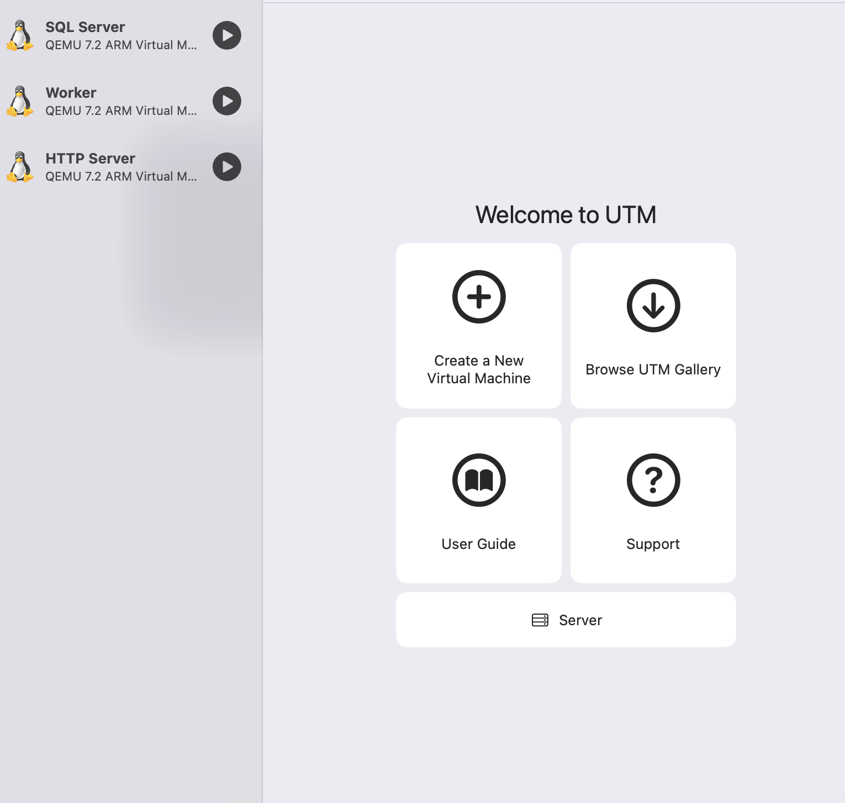

UFW was used to open the appropriate ports for the webserver and SQL server.

SQL map was used for testing the API for vulnerabities.

**Implementation:**

Disclaimer:

The PII referenced is artificial data randomly generated using a Node.js script, it bears no resemblance to actual people.

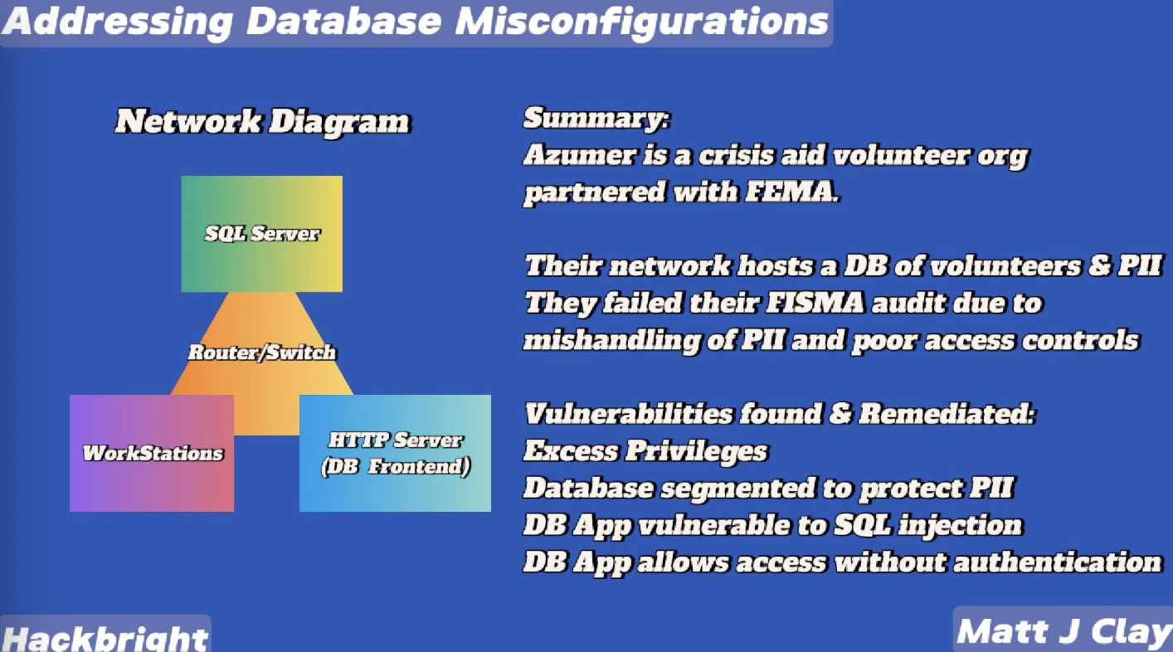

**I created a simulation of a small office at a volunteer organization. The org is called Azumer they are partnered with FEMA.**

**The scenario here is that they failed a FISMA audit due to mishandling PII.**

**I did a security assessment and identified some vulnerabilities relating to excess privileges, lack of access controls, data segmentation, and database misconfigurations.**

**I started by testing the search form for sql injections. I also ran SQLMap against the API. It detected sveral vulnerabilities, most notably a vulnerability using unions.**

**I was able to successfully get a result to return. This confirms that the input is not sanitized, the query would return nothing if it sanitized.**

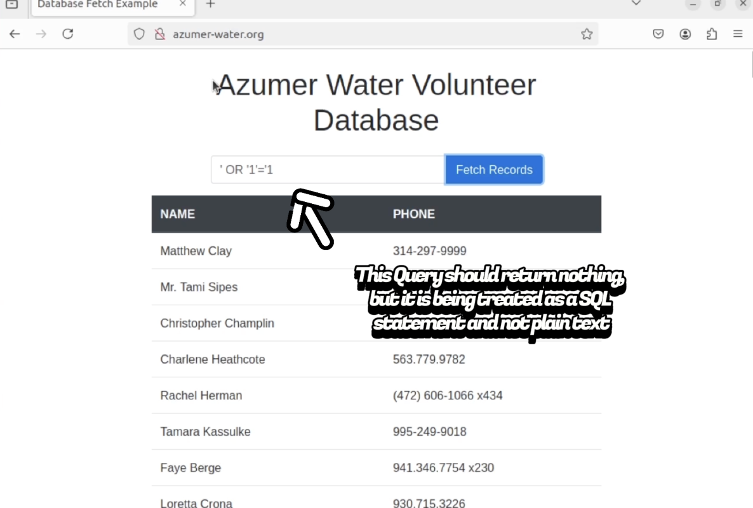

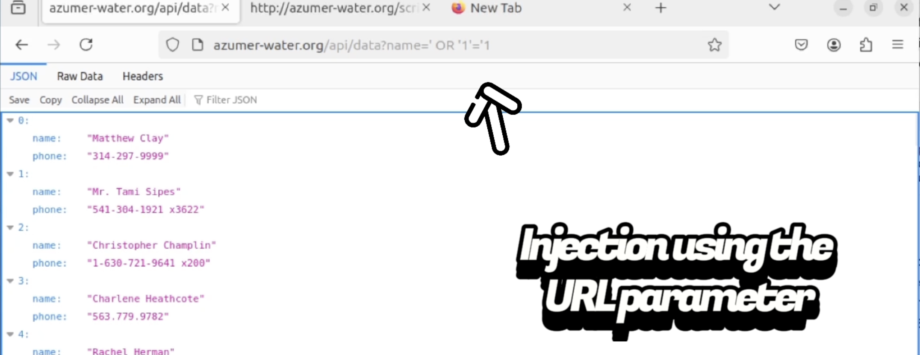

**The culprit is the following section of code, this coding error causes the server to treat input as a query rather than as a literal string (Plain Text)**

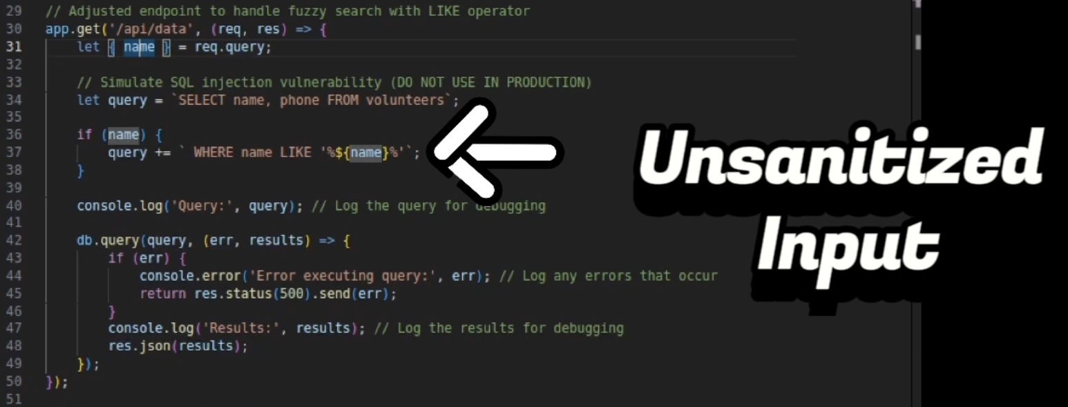

**I fixed the code and used parameterization to sanitize the input, this means that whatever information is posted to the API is treated as plain text, and will not be ran as a query.**

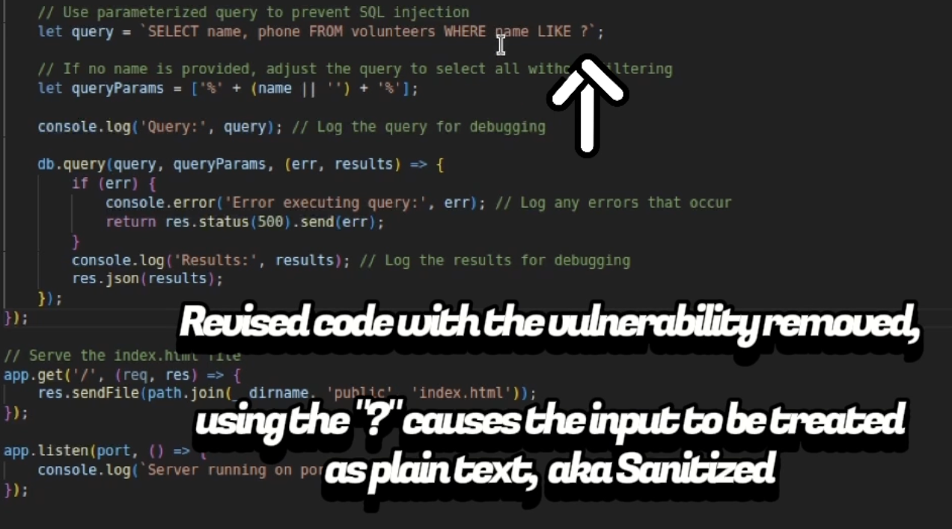

* **I then tested my work to ensure my fixes were implemented properly, no results were returned from my query, which means that my solution worked. I also ran SQL map on the backend to ensure I didn’t mess anything up.**

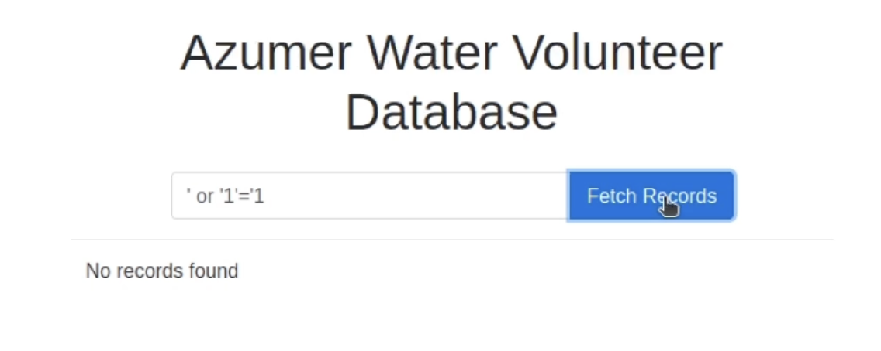

**The web app can be accessed without any authentication, allowing anyone access to the sensitive information.**

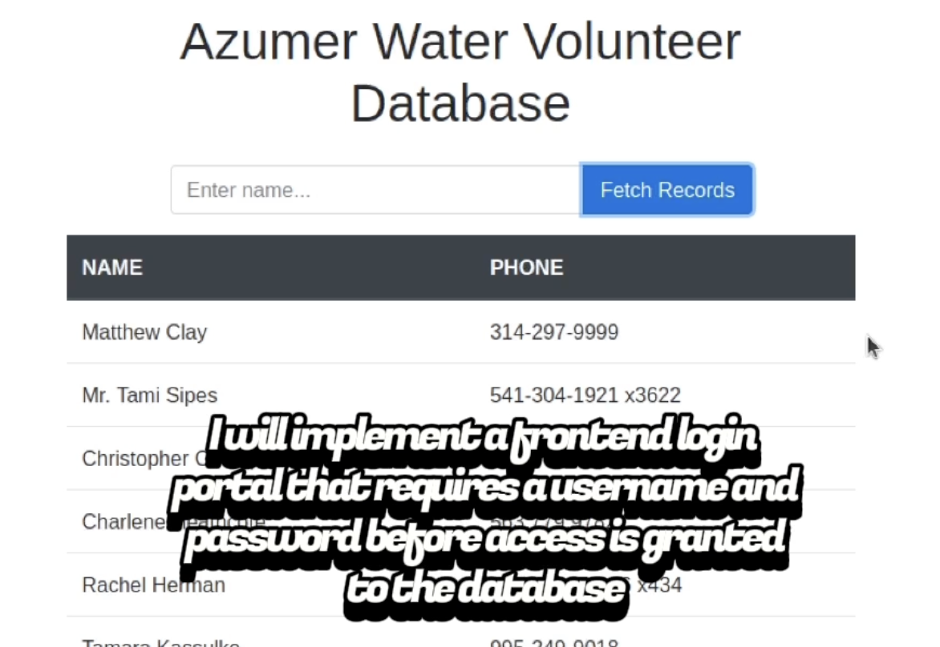

* **I created a login portal that requires a username and password. The login credentials are securely stored in a database, and hashed using sha-256.**

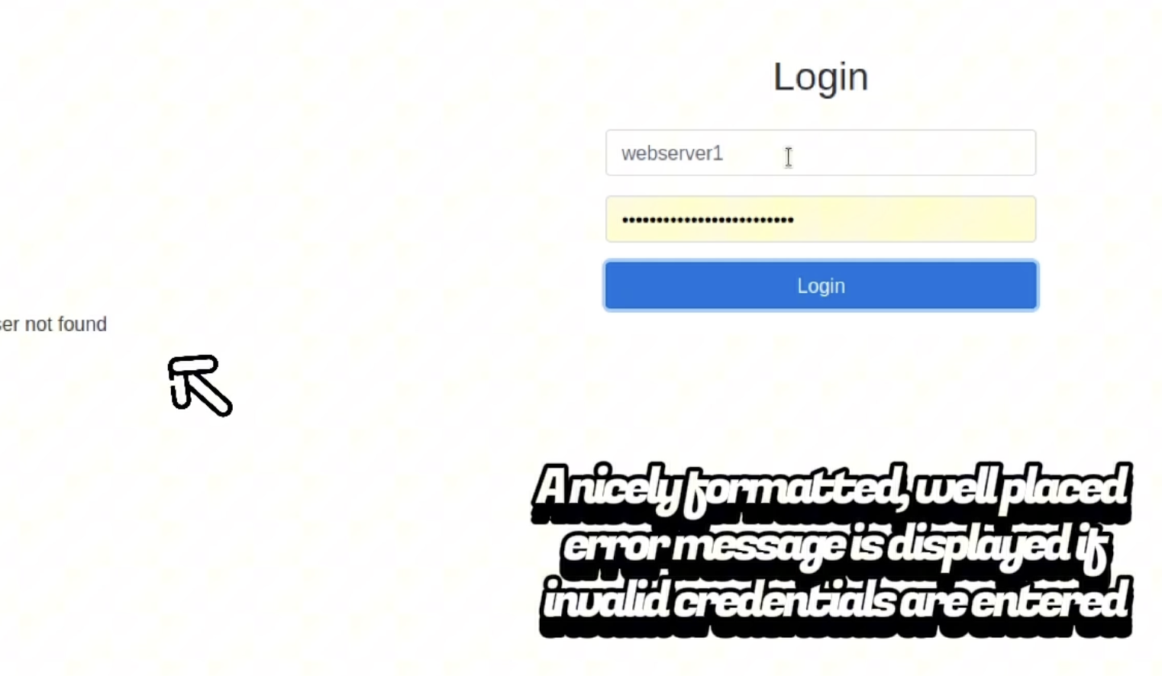

**I then established a connection to the database server from a workstation to determine what privileges a standard user has.**

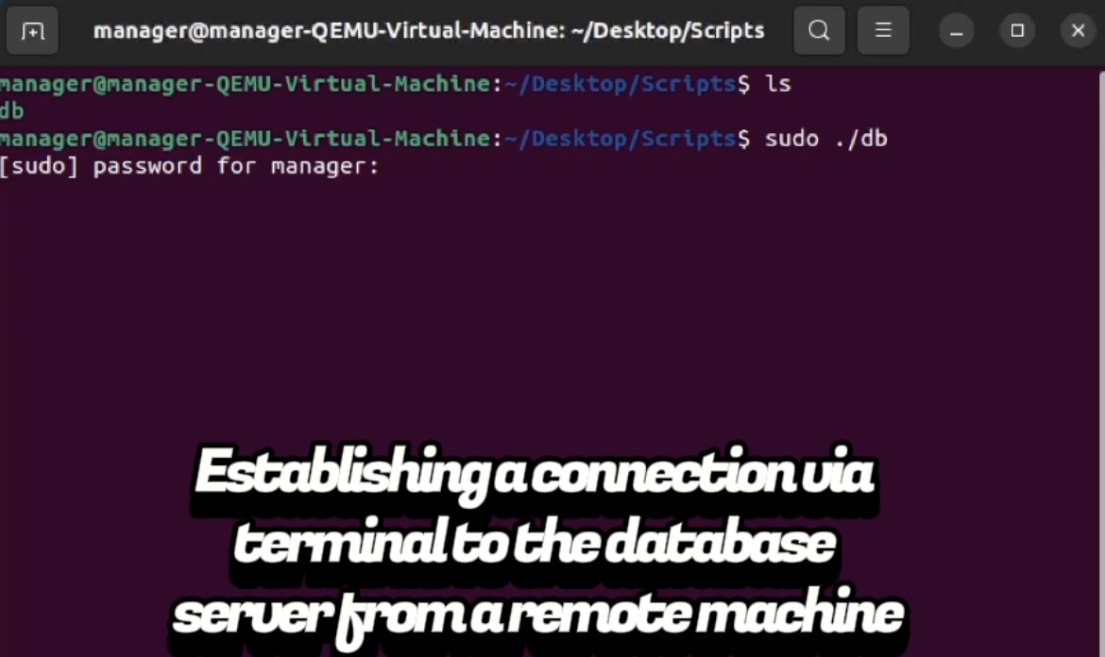

**The user has access to all internal databases by default. Including the database used by the web application for authentication purposes.**

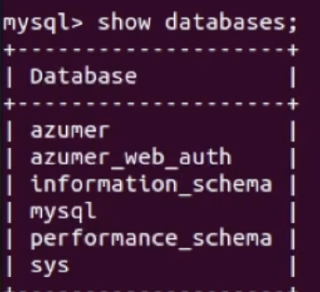

**I was able to select from the web_auth database and view the stored user and password**

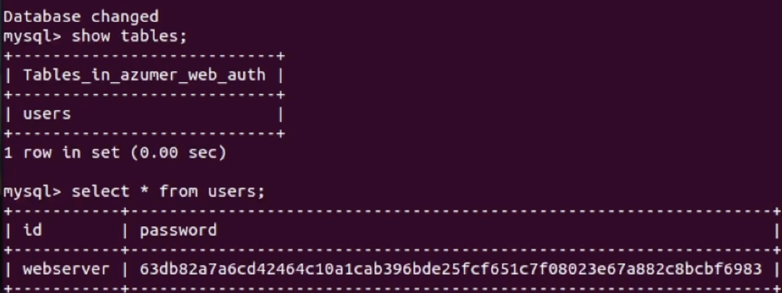

**I did a test to determine if I have insert privileges. Having these privileges could allow a user to modify the credentials to gain access to the database through the web portal.**

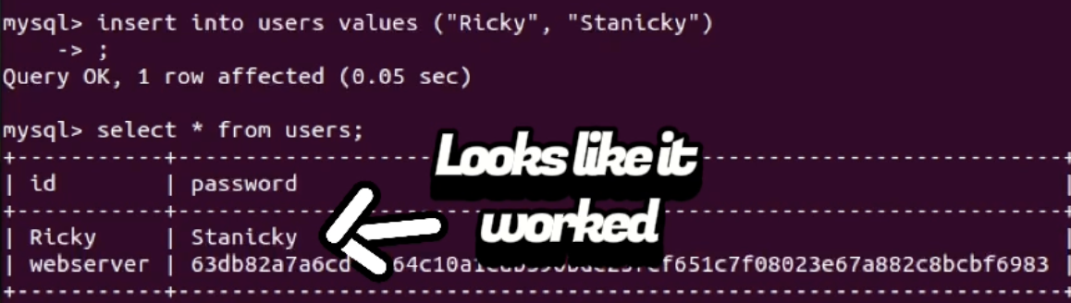

**I then did a test to determine what privileges I have on the volunteers table. The web portal was only returning a Name and Phone number. But theres a SSN column stored alongside this information in the same table.**

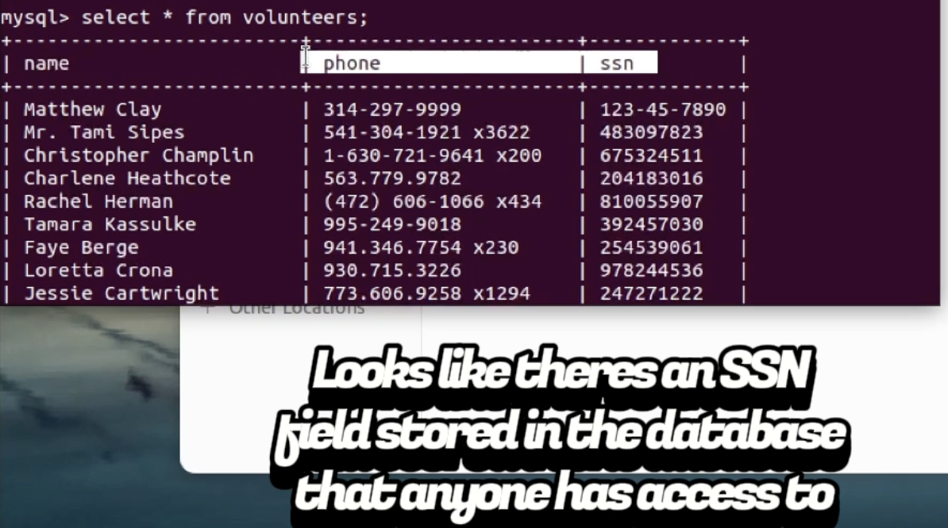

**I then did a query to view all grants on the database. This was done to get a complete view of everything. It would be too time consuming and impractical to test for all of these manually.**

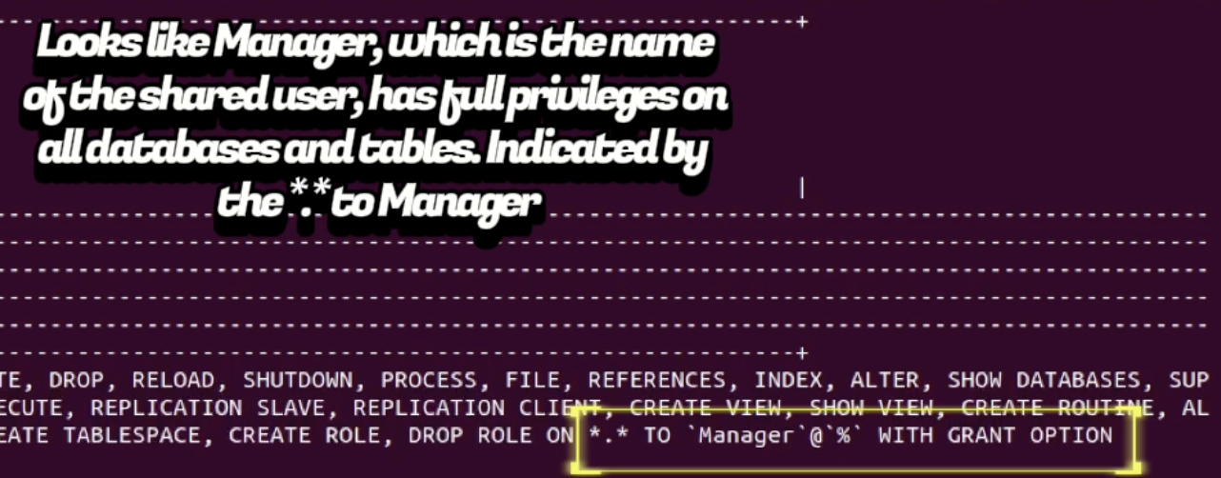

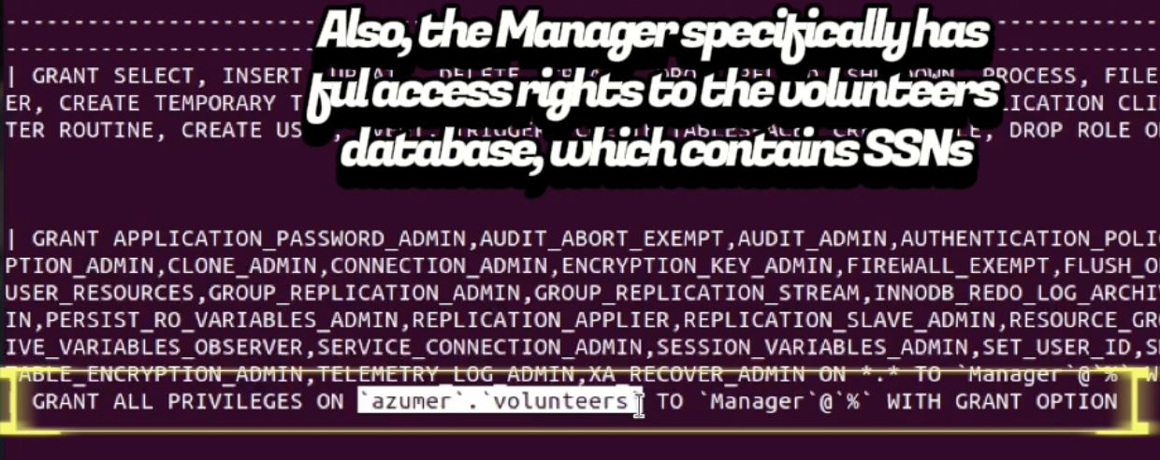

**The default user has grants for all privileges on all current and future tables. I revoked all privileges as a baseline of least privilege and will only grant access as needed.**

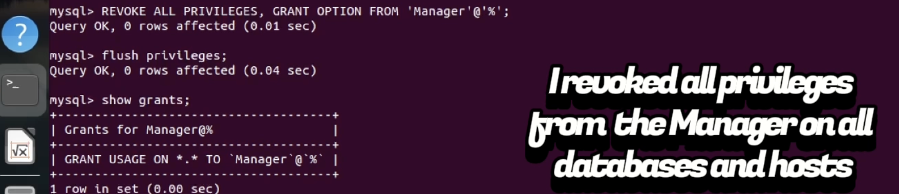

* **I then did a few tests to ensure the privileges were removed properly. I have no access to anything, which indicates that my changes went through successfully.**

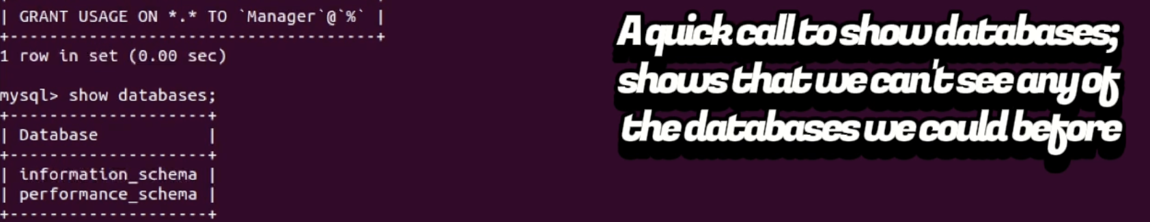

**I logged in as root on the database server and viewed a list of all users. This is to ensure I didn’t miss some lingering user that may have privileges that I missed.**

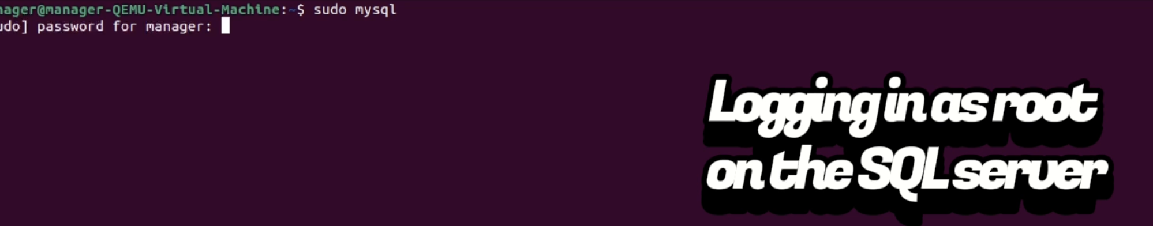

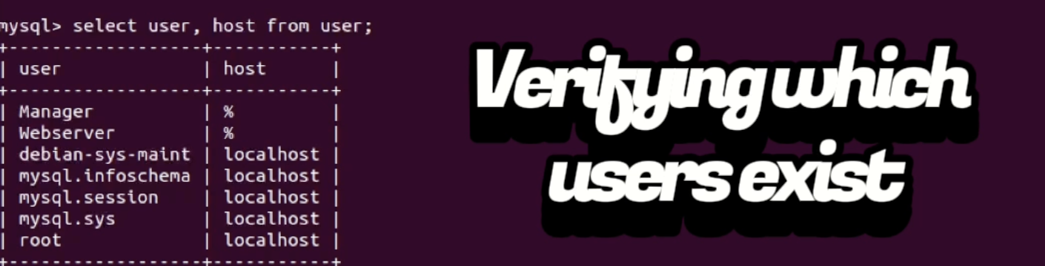

**I granted select only privileges to the user on the volunteers table. This means all that the user can do is send a query to request the contents of the table. The user is unable to modify or delete anything.**

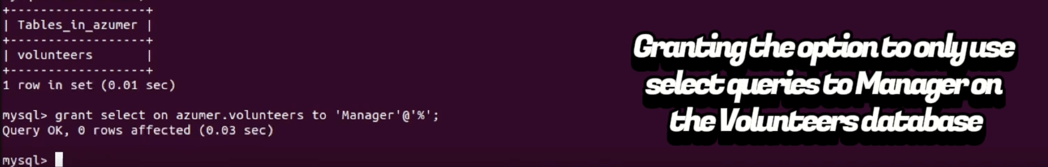

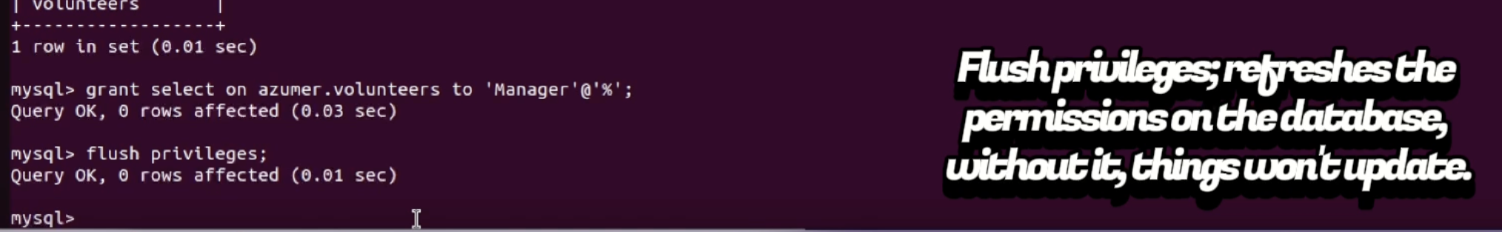

**I am testing my grants to ensure they were implemented properly. I can see the Azumer database and the volunteers table, and not the web_auth database. Which is exactly what I should be able to see.**

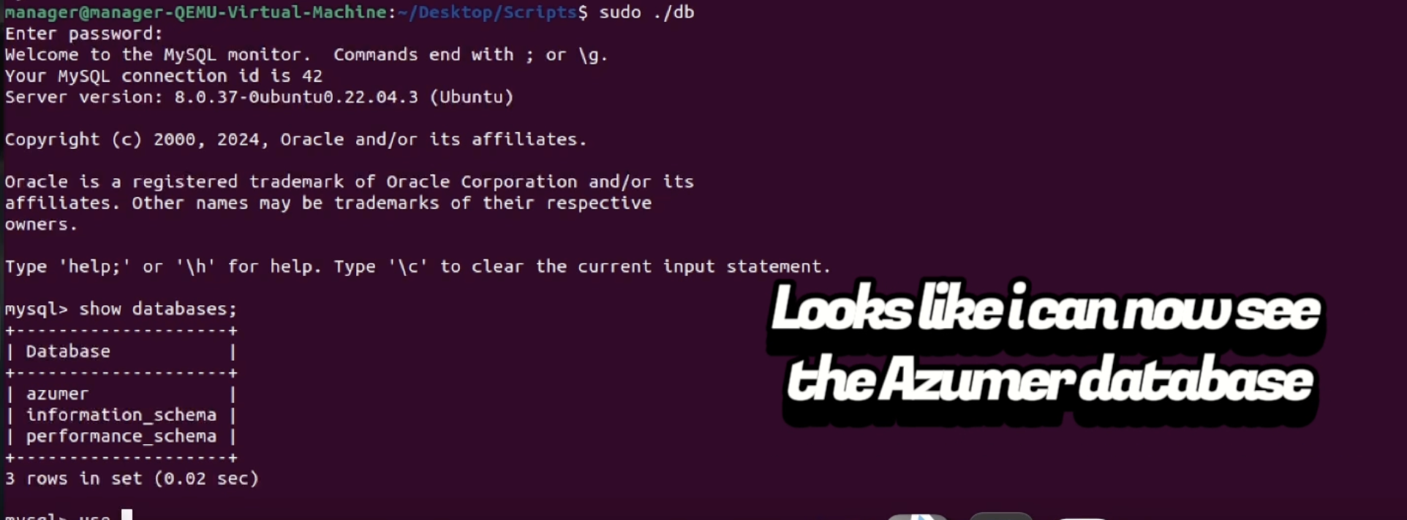

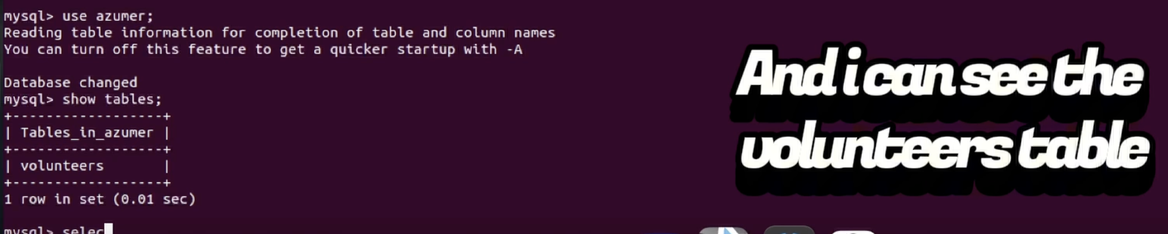

**Testing that I can use the select statement was successful.**

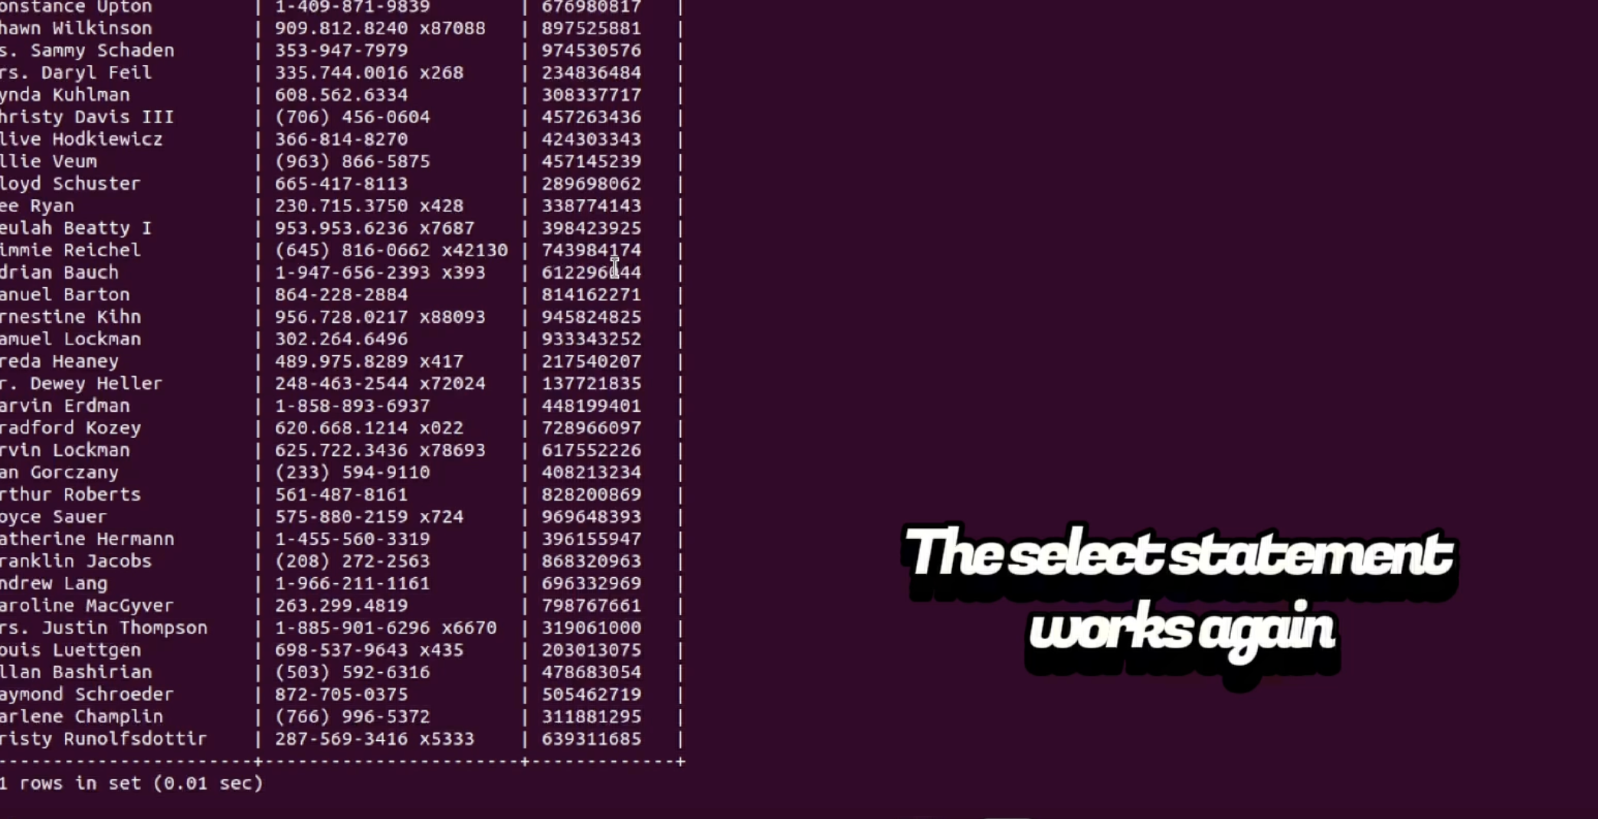

**I attempted an insert to verify I was properly denied access, it was rejected as expected.**

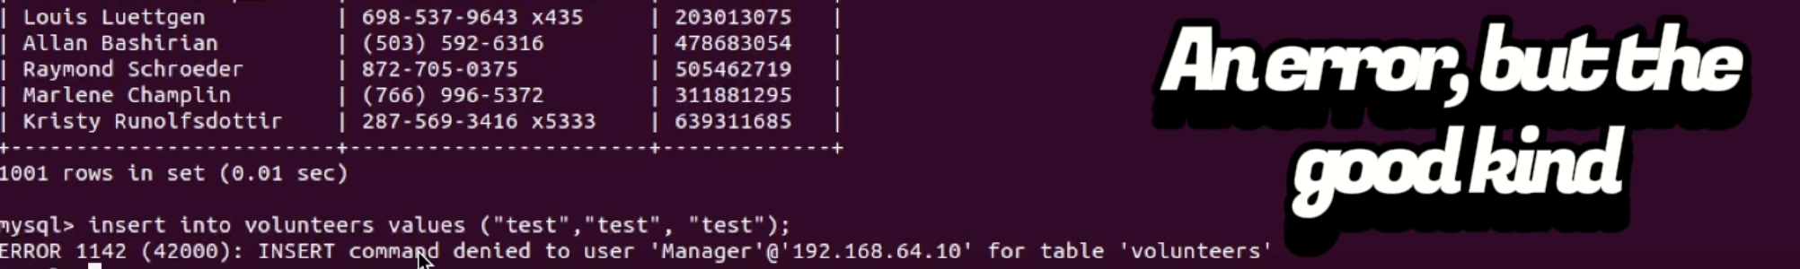

**I then started segementing the SSN from the volunteers table. By creating a new table for storing the PII, which uses a foreign key to reference the volunteers table. This can be used later on in a join statement to get the name, phone, and SSN of a volunteer. And it ensures that a name and phone has to exist in the parent table in order for an entry to be made in the SSN table.**

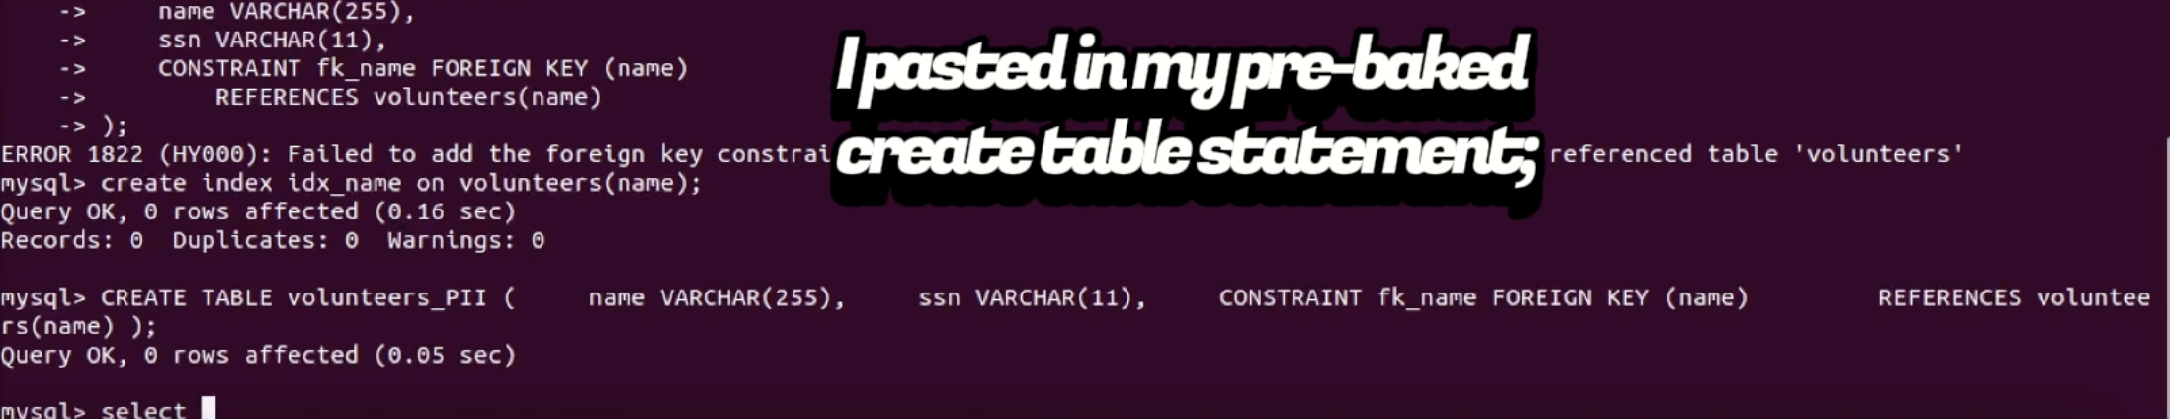

**I tested to verify my table was properly created.**

**I inserted dummy data to confirm the table was constructed properly.**

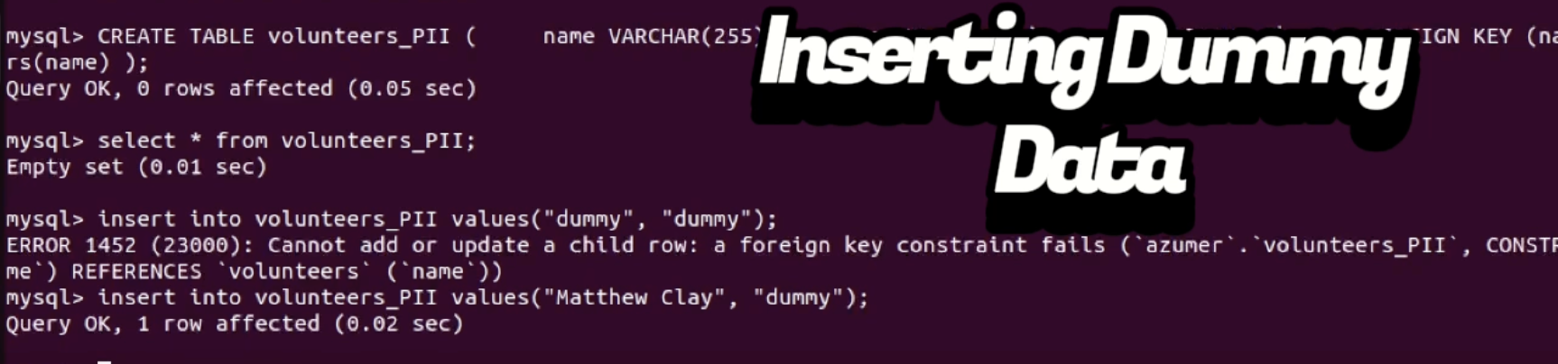

**I am copying the SSN and Name column from the volunteers table to the PII table. I did this by using a combined insert and select statement.**

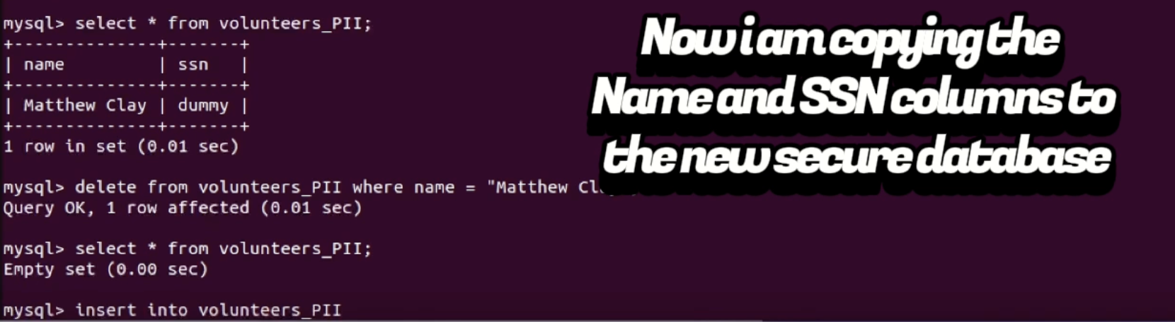

**After testing, I removed the columns from the Volunteers table.**

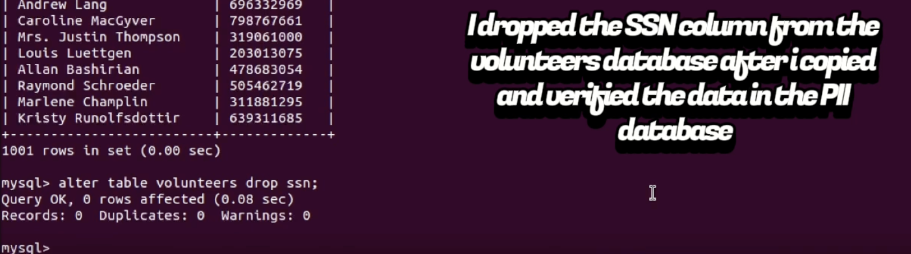

**I checked the first 10 items in each table to ensure the data was copied in order. This is to ensure referential integrity, so the SSN is not associated with the incorrect person.**

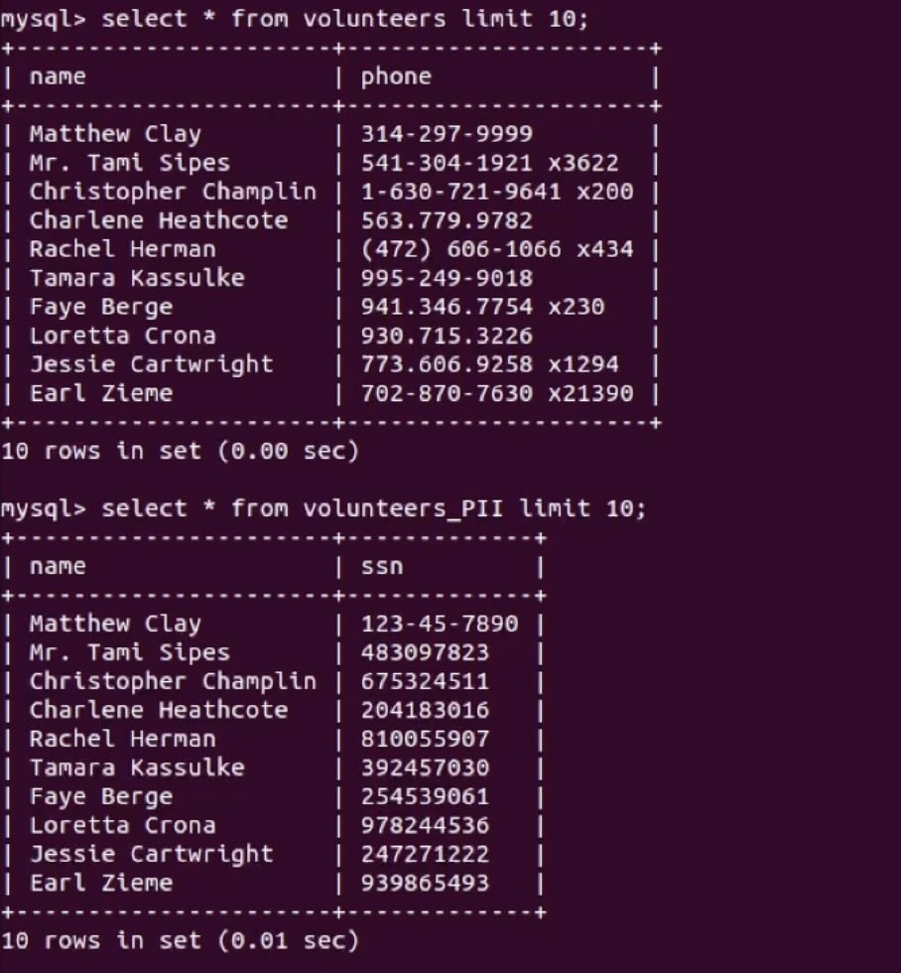

**Lastly I did a check to ensure the standard user does not have access to the PII table.**

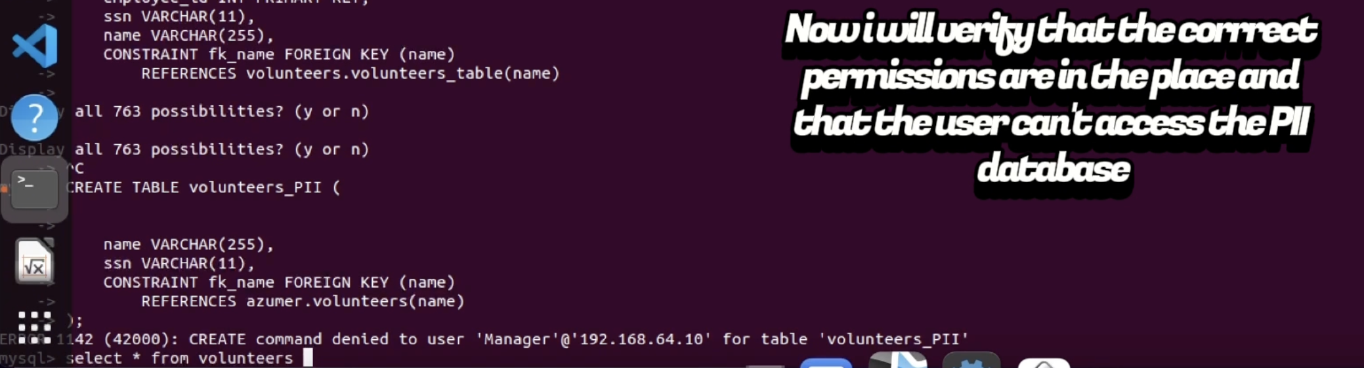

**Considerations:**

There’s still a lot more I would do to improve upon things. This is just the start.

First order of business would be to implement HTTPS properly and ensure a properly signed certficiate is in use. My dev environment for the simulation was using plain HTTP.

The network is not segmented. The workstations and the servers are on the same network. Putting the database server on a different network/vlan would be a better option. Also the PII should be handled a little more strict. I would put it on a separate database or server. That way if, in the future, the version of SQL running gets exploited, the risk of the PII being exposed is mitigated.

The password in the database is hashed securely with sha-256. But salt should also be added to safeguard against rainbow table attacks.

The PII that is stored in the database should be encrypted at rest and in transit.

It would be wise to separate admin privileges using separation of duties. The IT manager and the Security manager would each have split privileges on the PII database, as a form of checks and balances / oversight on each other.

The web application is very barebones, and hardly counts as an mvp. I would polish things up and do comprehensive testing to ensure the frontend login portal is secure.

I would make onsite and offsite encrypted backups of the database. And have some sort of automated process to do this. Availability is of extra importance in this scenario due to the organization being involved in crisis aid, and having volunteer contact info available 24/7 is critical.

I would ensure that proper access logs are in place for workstations, database access, and webserver access. I would send these off to an external logging server for safe keeping and review.

I would ensure very secure passwords are in use for administrator access on the servers. And I would do vulnerability scans against the servers to ensure they are secure and not using outdated software. I would also verify firewall rules are properly in place.

I would setup patch management and ensure systems are updated on a regular schedule during off hours. And have a rollback plan in place in the event of an issue.

I would also ensure a BCP plan is in place, in the event that, despite our best efforts, a breach or outage occurs. We can roll back to a working version quickly.

**Transcript:**

**Intro:**

**My name is Matt Clay**

**I created a simulation of a small office at a volunteer organization. The org is called Azumer they are partnered with FEMA.**

**The scenario here is that they failed a FISMA audit due to mishandling PII.**

**I did a security assessment and identified some vulnerabilities relating to excess privileges, lack of access controls, data segmentation, and database misconfigurations.**

**The following presentation is a breakdown of the steps I took to remediate the issues.**

* **I started by testing the search form for sql injections.**
* **I was able to get my injection to return data**
* **I checked the page source for exposed APIs**
* **I found a target and attempted a sql injection**
* **using a url parameter**
* **I was able to get my injection to return data, which indicates that it is vulnerable**
* **The backend server is not sanitizing input**
* **I fixed the code and used parameterization to sanitize the input**
* **This causes input to be treated as text and not a query**
* **I then tested my work to ensure my fixes were implemented properly**
* **No results were returned from my query, which means my fixes were implemented properly**
* **The web app can be accessed without any authentication, allowing anyone access to the sensitive information.**
* **I created a login portal that requires a username and password**
* **The password is securely stored and hashed using sha-256**
* **I then established a connection to the database server from a workstation to determine what privileges a standard user has**
* **The user has access to all internal databases by default**
* **I was able to select from the web_auth database and view the stored user and password**
* **I did a test to determine if I have insert privileges**
* **I was able to perform my insert successfully**
* **I then did a test to determine what privileges I have on the volunteers table**
* **I have full access to the underlying sensitive information – including the SSN column**
* **I then did a query to view all grants on the database**
* **The user has full grants on everything on all databases and tables by default**
* **The user also has all grants on the volunteers table**
* **I first revoked all privileges as a baseline**
* **I then did a few tests to ensure the privileges were removed properly**
* **I logged in as root on the database server and viewed a list of all users**
* **I granted select only privileges to the user on the volunteers table**
* **I flushed privileges to do a force update**
* **I am testing my grants to ensure they were implemented properly**
* **I am able to see the volunteers table as expected**
* **I am also able to run a select query as expected**
* **I attempted an insert to verify I was properly denied access, it was rejected as expected**
* **I then started segementing the SSN from the volunteers table**
* **I tested to verify my table was properly created**
* **I inserted dummy data to confirm the table was constructed properly**
* **I am copying the SSN and Name column from the volunteers table to the PII table**
* **After testing, I removed the columns from the Volunteers table**
* **I checked the first 10 items in each table to ensure the data was copied in order**
* **Lastly I did a check to ensure the standard user does not have access to the PII table.**